Encounter: Think of the Children!

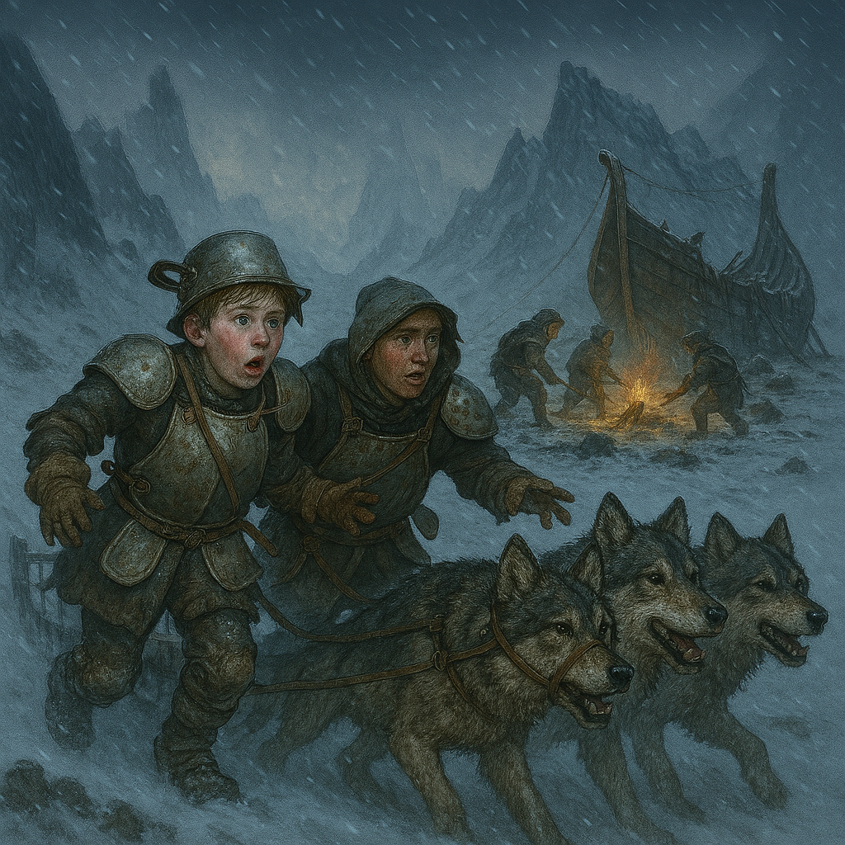

Encounter Setup

As dawn breaks on the second day, heavy flakes drift from a slanting sky, muffling the world in an increasingly cold silence. As the party gathers in the pale morning light, the crew boss approaches with an update: “We’re lucky that old horseshoe quarry’s so close. Found a stash of iron scraps and tools yesterday—helped patch the hull faster than I’d hoped.”
Just as the exhausted crew patches the final holes in the hull, a distant yipping and the rhythmic scrape of runners slice through the hush. Two nord children—maybe teenage siblings—burst into the camp atop a battered dogsled. The children are clad in makeshift armor cobbled together from pots, pans, and kitchen scraps, their cheeks ruddy and eyes wide with fear.
(show photo)
They stammer out a frantic warning: their up-mountain village has been “overrun by elves,” pale shapes moving in packs, eyes glazed and motions stiff. Through shivers and stutters, they beg for protection, insisting their families were taken in the night. If the party takes the time to listen, the children’s terror is unmistakable—the younger one defiently clutches a bent ladle like a dagger.
Villager Children Dialog – Answering Player Questions
Who are you?
- “We’re from the village up the mountain. I’m Sigrid, and this is my brother, Toren. We came as fast as we could.”
What happened to your village?
- “The elves came in the night. They weren’t normal—pale, with empty eyes. They took our families. We barely escaped.”
Are there any survivors?
- “I think some people hid in the old mill. But most were dragged away. We don’t know where.”
What do you know about the attackers?
- “They moved like they were sleepwalking. Some had mushrooms growing from their faces. I heard them humming, like a song with no words.”
Is there anywhere safe nearby?
- “The quarry is empty, but it’s cold. We saw tracks—maybe from the elves, maybe from something else. We just want to find our parents.”
How did you get here?
- “We took the dogsled. It’s all we had left. The snow was deep, but the dogs are strong.”
Can you fight?
- “We’re not warriors. But I won’t let anyone take Toren. I have my ladle, and I’ll use it if I have to.”
Should the party dismiss the warning as childish fantasy, the tension in the air thickens. Shadows flicker at the treeline, and the silence grows oppressive. Moments later, the forest erupts. A horde of spore servants—once townsfolk, now twisted by fungal growth—descends upon the camp, their eyes vacant and movements jerky.
The “elves” are spore servants of the skeletal frost giant

As battle chaos consumes the camp, a thunderous rumble echoes from higher up. Out of the swirling flurries, a monstrous ice ball, bristling with jagged spikes and pushed by a swarm of Thorny Hunters, crashes down the slope. With a bone-cracking shatter, the ice splits, and from its heart rises a towering Mycelial Frost Giant Skeleton—a frost giant animated not by flesh, but by tangled fungal growths and shimmering hyphae, its bones rimed with ice and spore clusters. The giant bellows, scattering friend and foe alike, and wades into the melee, each step shaking the snowy earth.
With the ship barely seaworthy and the camp being overrun, the party faces a desperate choice: make a stand against overwhelming odds, or abandon everything and flee to the uncertain safety of the open water as the giant and its fungal horde press their relentless assault.
The children’s fears manifest as reality, catching the party unprepared amid half-packed supplies and scattered weapons.
As battle chaos consumes the camp, a thunderous rumble echoes from higher up. Out of the swirling flurries, a monstrous ice ball, bristling with jagged spikes and pushed by a swarm of spineys, crashes down the slope. With a bone-cracking shatter, the ice splits, and from its heart rises an ice giant, frost clinging to its pale skeleton. The erupts in a spore infestation, scattering friend and foe alike, and wades into the melee, each step shaking the snowy earth.
With the ship barely seaworthy and the camp being overrun, the party faces a desperate choice: make a stand against overwhelming odds, or abandon everything and flee to the uncertain safety of the open water as the giant and its fungal horde press their relentless assault.

Thorny Hunter (3)
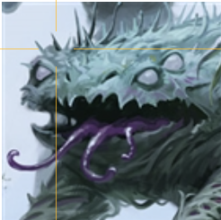
Medium plant, unaligned
Armor Class: 14 (natural armor)
Hit Points: 85 (10d8 + 40)
Speed: 40 ft.
STR 18 (+4) DEX 14 (+2) CON 18 (+4) INT 3 (-4) WIS 12 (+1) CHA 5 (-3)
Saving Throws: Con +7
Skills: Perception +3, Stealth +4
Damage Resistances: cold, poison
Condition Immunities: blinded, deafened, poisoned
Senses: blindsight 30 ft. (blind beyond this radius), passive Perception 13
Challenge: 5 (1,800 XP)
Traits:
- Spore Link: Shares sensory input with other spore-connected creatures within 120 ft.
- Fungal Camouflage: Advantage on Stealth checks in snowy or wooded terrain.
Actions:
- Multiattack: Makes two Thorn Lash attacks.
- Thorn Lash: Melee Weapon Attack: +7 to hit, reach 10 ft., one target. Hit: 12 (2d6 + 4) piercing damage.
- Spore Burst (Recharge 5–6): Releases spores in 10-ft radius. DC 14 Con save or poisoned for 1 minute. Disadvantage on attack rolls while poisoned.

Mycelial Frost Giant Skeleton
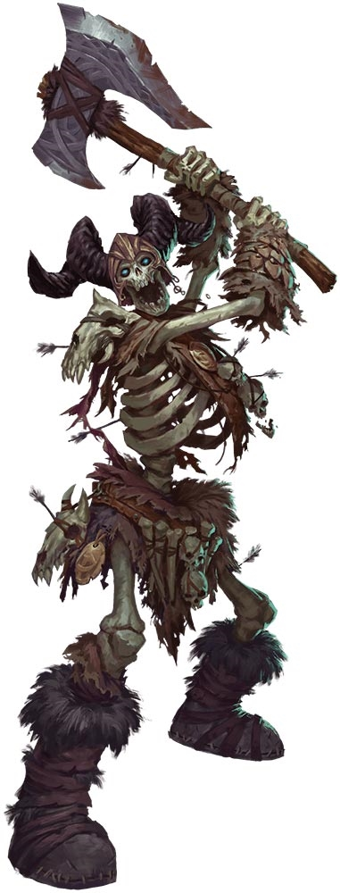
Huge undead, chaotic evil
Armor Class: 15 (natural armor)
Hit Points: 168 (16d12 + 64)
Speed: 40 ft.
STR 23 (+6) DEX 9 (-1) CON 19 (+4) INT 5 (-3) WIS 8 (-1) CHA 5 (-3)
Saving Throws: Con +7
Damage Resistances: cold, necrotic
Condition Immunities: poisoned, exhaustion
Senses: darkvision 60 ft., passive Perception 9
Languages: understands Giant but can't speak
Challenge: 9 (5,000 XP)
Traits:
- Spore Infestation (Recharge 6): Emits necrotic spores in 30-ft radius. DC 16 Con save or take 6d8 necrotic damage and become infected. Infected creatures must save at end of each long rest or gain 1 level of exhaustion. 3 failed saves = death and transformation into Spore Servant.
- Cosmic Echoes: Emits a low hum. Creatures within 10 ft. must make DC 14 Wis save or be frightened until end of next turn.
Actions:
- Greatclub: +9 to hit, reach 10 ft., one target. Hit: 25 (3d8 + 6) bludgeoning damage.
- Rock Throw: Ranged Weapon Attack: +9 to hit, range 60/240 ft., one target. Hit: 28 (4d10 + 6) bludgeoning damage.

Spore Servant
  - Undead Minion of the Mycelial Frost Giant
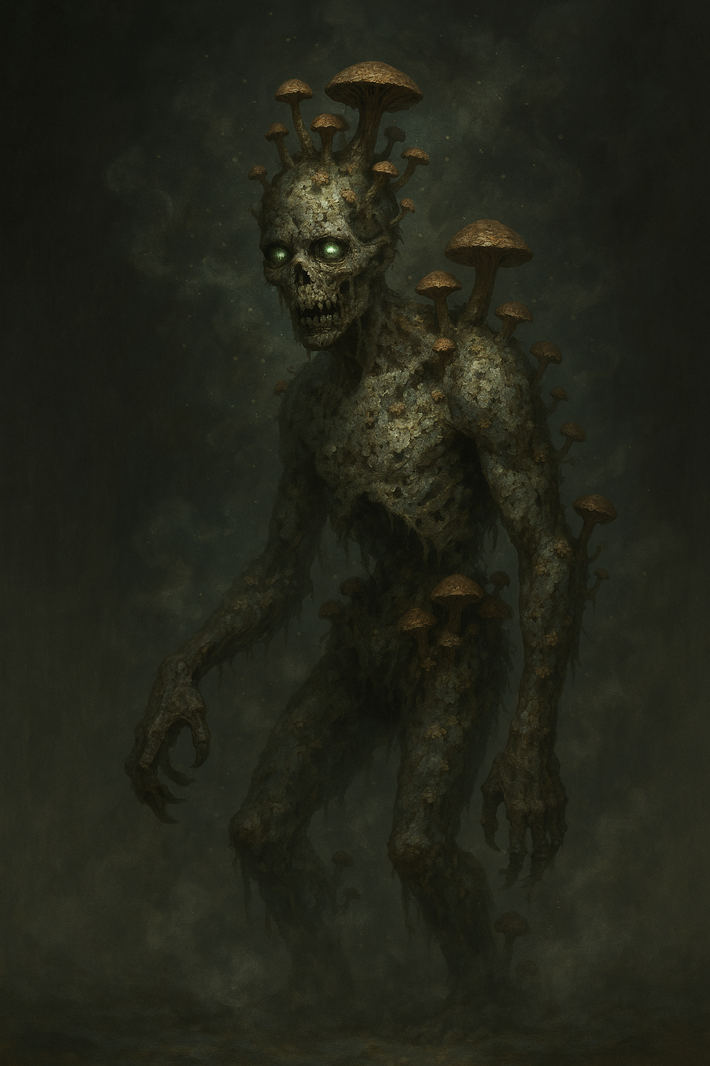

Stat Block
Type | Medium undead, unaligned
Armor Class | 8 (natural armor)
Hit Points | 22 (5d8)
Speed | 20 ft.
STR | 16 (+3)
DEX | 6 (-2)
CON | 15 (+2)
INT | 2 (-4)
WIS | 6 (-2)
CHA | 1 (-5)
Damage Resistances | cold, poison
Condition Immunities | poisoned, exhaustion
Senses | darkvision 60 ft., passive Perception 8
Languages | understands languages it knew in life but can't speak
Challenge | 1/2 (100 XP)

Traits
- Spore Infestation: The Spore Servant continually sheds necrotic spores. When a creature starts its turn within 5 ft., it must succeed on a DC 12 Constitution saving throw or take 1d6 poison damage and be poisoned for 1 minute.
- Undead Nature: The Spore Servant does not require air, food, drink, or sleep.

Actions
- Slam. Melee Weapon Attack: +5 to hit, reach 5 ft., one target. Hit: 7 (1d8 + 3) bludgeoning damage.

Origin
Spore Servants are created when victims succumb to the necrotic spores emitted by the Mycelial Frost Giant Skeleton. After three failed saving throws against spore infection, a creature dies and rises as a Spore Servant under the control of its fungal master.

Treasure
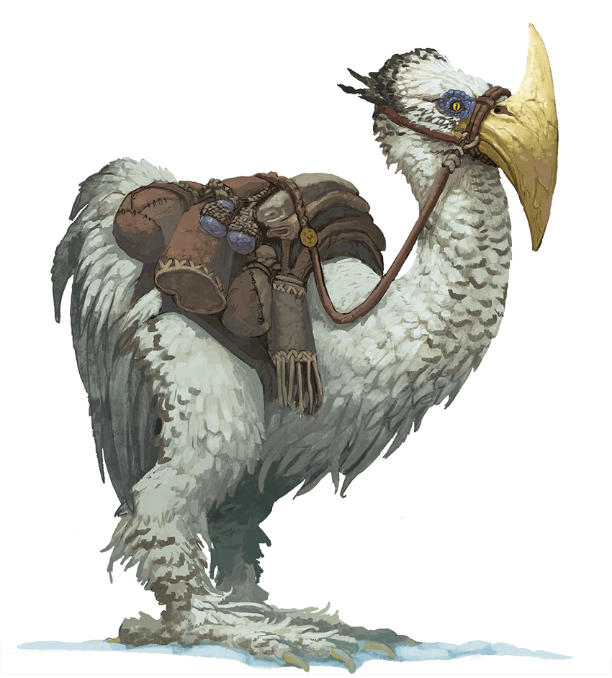
As the echoes of battle fade, you search the battered clearing for signs of what came before. Scattered across the ground are the remnants of another party—broken climbing ropes, ice axes, and torn packs, all dusted with frost and stained by struggle.
Among the debris, you spot a hay wagon, its contents mostly intact. To your surprise, several Axe Beaks—large, powerful birds with sharp beaks and wary eyes—are still tethered to a sturdy tree nearby. They seem untouched by whatever claimed the previous group, pecking contentedly at the hay and watching you with curious, hopeful interest.
While the fate of the lost party is grim, the Axe Beaks appear healthy and eager for attention—a rare stroke of luck in this bleak landscape.
The spore-connected creatures do not carry traditional treasure, but the following can be found in their lairs:
- 1d4 Potions of Greater Healing (buried satchel near cave entrance)
- Frost-covered chest: 300 gp, 2 gems (100 gp each), Wand of the Warmage
- Fungal-covered corpse: +1 Shield, Scroll of Protection from Energy
- Glowing red mushrooms (DC 15 Nature check): Can be harvested to craft Potion of Resistance (cold)
- 6 Axe-beaks
